SIMATS ENGINEERING
ASSESSMENT TOOL 1

COURSE NAME: COMPUTER ARCHITECTURE COURSE CODE: CSA1202
NAME :YAZHINI.E.M
REG NO:192511165
Computer Organization & Architecture
Assignment: CPU, Memory, I/O Interaction, Bus Structures, Instruction Cycle, CPI & 8085 Addressing Modes

Question 1: Smart City Surveillance System — Bus Structures & CPU–Memory–I/O Interaction

1.1 Restating the Problem
A smart-city surveillance network has dozens of cameras continuously streaming video. Each frame must travel from the camera (I/O device) into main memory, and the CPU must periodically read frames from memory, run detection algorithms, and write results/alerts back. During peak hours (e.g., rush hour, a public event) the volume of simultaneous transfers rises sharply, and the system starts lagging — threats are detected late.

1.2 How CPU, Memory and I/O Interact
Every one of the three subsystems is connected through a system bus consisting of three logical parts:
- Address Bus — carries the memory/I/O address the CPU wants to access (unidirectional, CPU → others).
- Data Bus — carries the actual data being transferred (bidirectional).
- Control Bus — carries control/timing signals such as Read, Write, Interrupt Request, DMA Request, Ready/Wait (bidirectional).
For a surveillance workload, three kinds of transfers are constantly competing for these buses:
- I/O → Memory: incoming video frames from each camera controller are written into buffers in RAM (often via DMA).
- Memory → CPU: the CPU fetches frame data and its own instructions from memory to run detection/analysis.
- CPU → I/O: control signals / alert data are sent out to actuators, alarms, or storage devices.
Because CPU speed (GHz) is far higher than I/O device speed and memory access is also slower than the CPU, a queue builds up whenever many of these transfers must share one physical pathway. This mismatch — combined with contention for a shared bus — is the direct technical cause of the lag observed in the surveillance system.

1.3 Single-Bus Architecture — Why It Struggles Under Load
In a single-bus (shared bus) architecture, the CPU, memory and all I/O devices are connected to one common set of address/data/control lines.
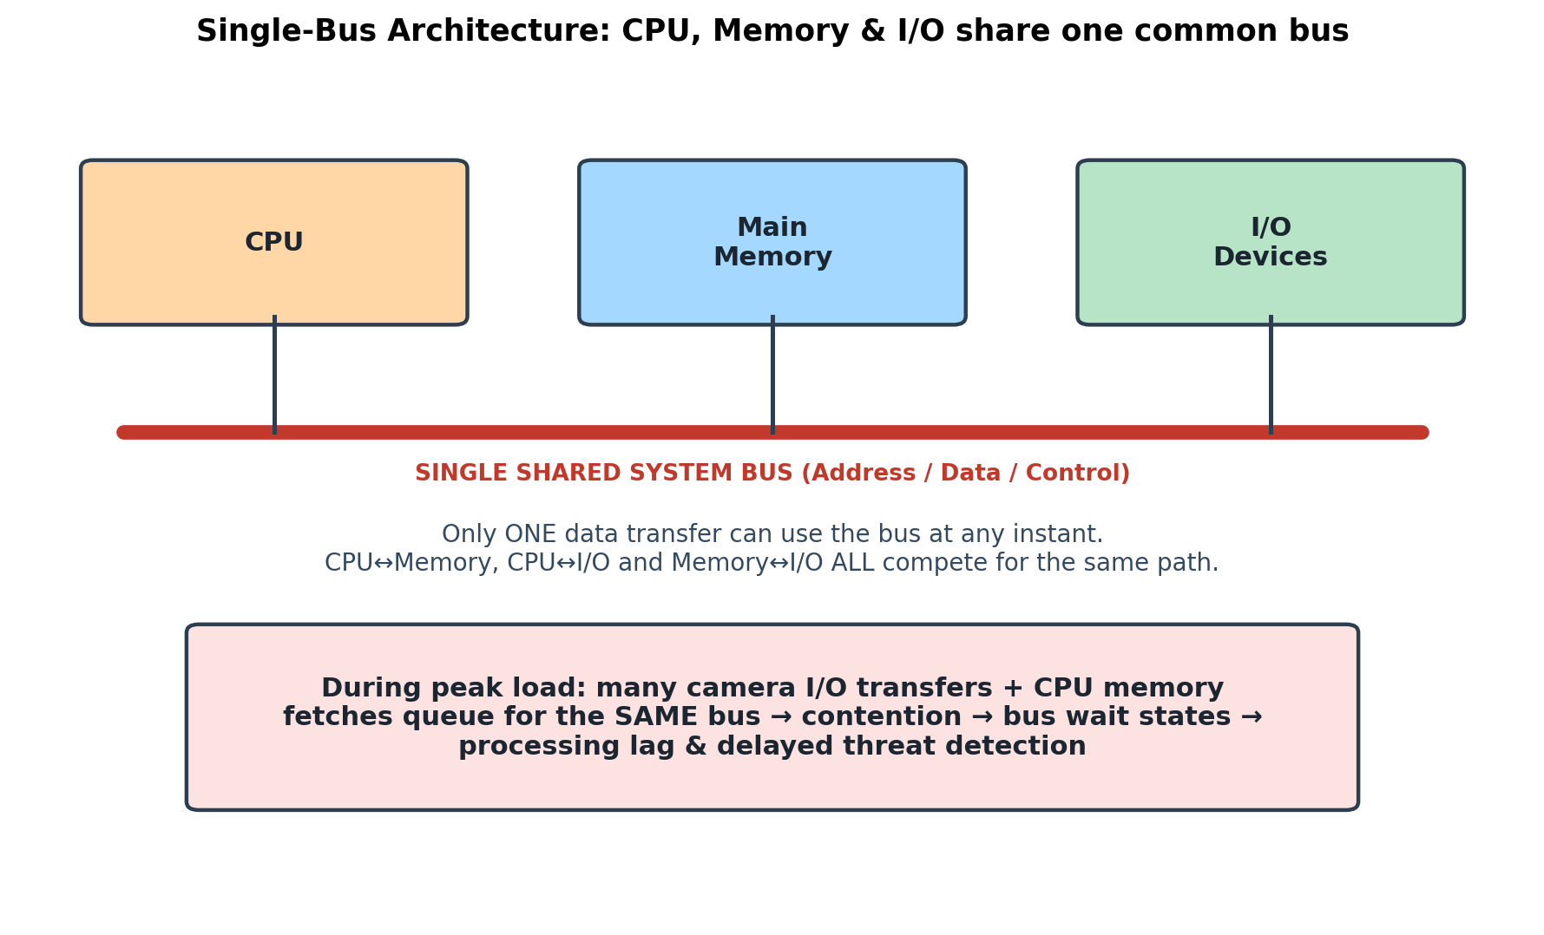
Figure 1.1 — Single shared bus: CPU, Memory and I/O all contend for one path
- Simplicity & low cost: fewer wires, simpler controller design, easy to expand with more devices.
- Bottleneck: only ONE transfer can occur on the bus at any given clock cycle. If cameras are flooding the bus with frame-write requests, the CPU's own fetch of the next instruction/data must WAIT.
- Bus arbitration overhead: an arbiter must grant bus ownership to one requester at a time (fixed priority / round robin / daisy chaining), which itself adds delay under heavy contention.
Under peak surveillance load this produces exactly the symptom described: growing wait-states, delayed frame delivery to the CPU, and hence late threat detection.

1.4 Multi-Bus Architecture — The Improvement
A multi-bus (multiple-bus) architecture provides separate, often simultaneous, pathways — typically a dedicated high-speed memory bus between CPU and RAM, and a separate I/O bus (sometimes bridged through an I/O controller/cache), possibly with a DMA controller managing I/O transfers independently of the CPU.
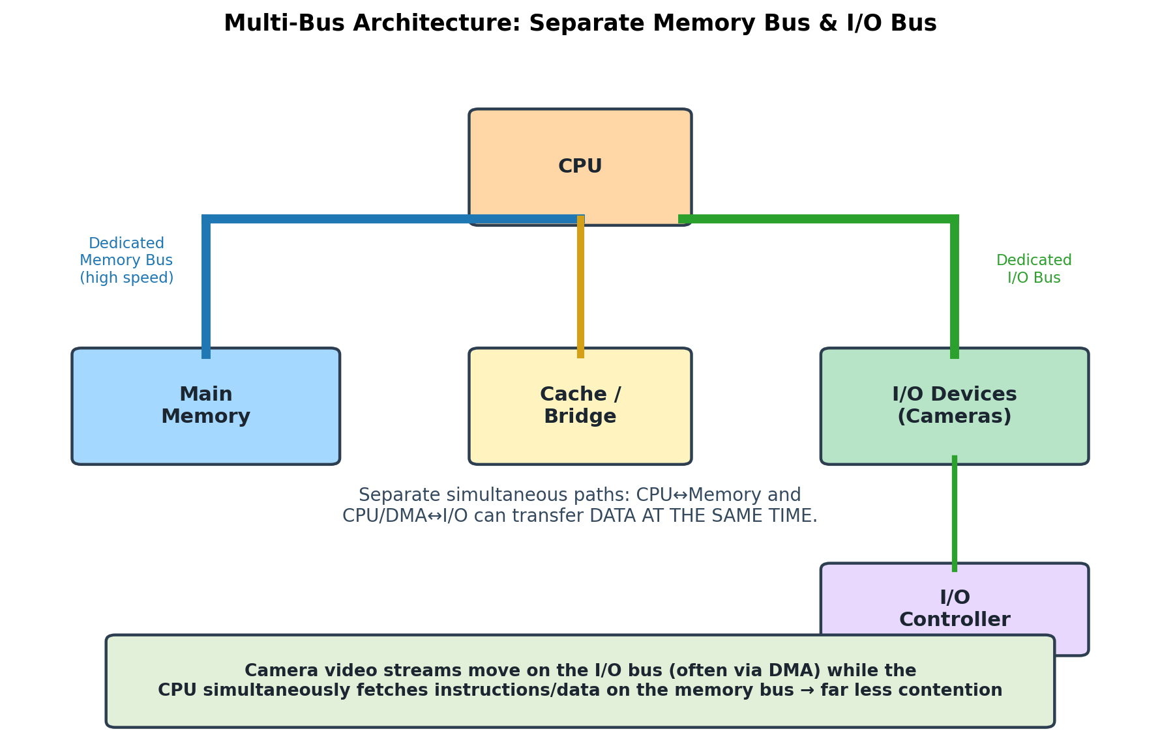
Figure 1.2 — Multi-bus architecture: dedicated memory bus and I/O bus operate in parallel
- Parallelism: the CPU can fetch instructions/data on the memory bus WHILE camera frames are simultaneously being DMA-transferred into memory on the I/O bus.
- Reduced contention: since traffic is distributed across multiple buses, peak-hour camera traffic no longer directly stalls every CPU memory access.
- Scalability: more cameras/devices can be added on the I/O bus without proportionally slowing down CPU–memory traffic.
- Trade-off: higher hardware cost and more complex synchronization/arbitration logic between buses.

1.5 Comparison
Aspect | Single-Bus | Multi-Bus
Transfers at once | Only one | Multiple, in parallel
Cost & complexity | Low | Higher (more controllers/wiring)
Performance under heavy I/O load | Degrades sharply (contention) | Sustained (I/O and CPU paths separated)
Best suited for | Small / low-traffic embedded systems | High-throughput real-time systems (e.g. surveillance)

1.6 Role of Improving the Instruction Execution Cycle
Beyond the bus, the CPU's own fetch–decode–execute cycle can be optimized so each frame-analysis instruction completes faster and frees the bus/CPU sooner:
- Pipelining: overlap fetch of the next instruction with decode/execute of the current one, increasing instruction throughput.
- Cache memory: keep frequently used detection-model data/instructions close to the CPU, cutting the number of slow main-memory accesses (hence less bus traffic).
- DMA (Direct Memory Access): let camera controllers write frames directly into memory without CPU intervention on every byte, freeing the CPU/bus for analysis work.
- Interrupt-driven I/O instead of polling: CPU is notified only when a frame is ready, instead of wasting cycles repeatedly checking device status.
- Wider data bus / burst transfers: move larger chunks of frame data per bus cycle, reducing the number of arbitration rounds needed.

1.7 Conclusion (Q1)
The lag during peak hours is caused by bus contention among concurrent CPU, memory and I/O transfers, worsened by a single shared bus. Moving to a multi-bus architecture with dedicated memory/I/O paths, combined with DMA, caching, interrupt-driven I/O and pipelined instruction execution, removes the bottleneck and restores real-time responsiveness for threat detection.

Question 2: Real-Time Stock Trading System — CPI, Execution Time & Architectural Enhancements

2.1 Restating the Problem
A trading processor executes millions of instructions per second, yet users see delays during high load. The diagnosis given is a HIGH CPI (Cycles Per Instruction) driven by frequent memory accesses and branch instructions — both of which are common in transaction-matching / order-book logic (lots of conditional checks and data lookups).

2.2 The Performance Equation
CPU execution time is governed by the classic performance equation:
Execution Time = Instruction Count (IC) x CPI x Clock Cycle Time
= IC x CPI / Clock Frequency
Increasing CPI directly and linearly increases execution time for the same instruction count and clock speed — this is exactly why a high CPI causes transaction delays even on a fast, high-frequency processor.

2.3 How the Fetch–Decode–Execute Cycle Impacts Execution Time
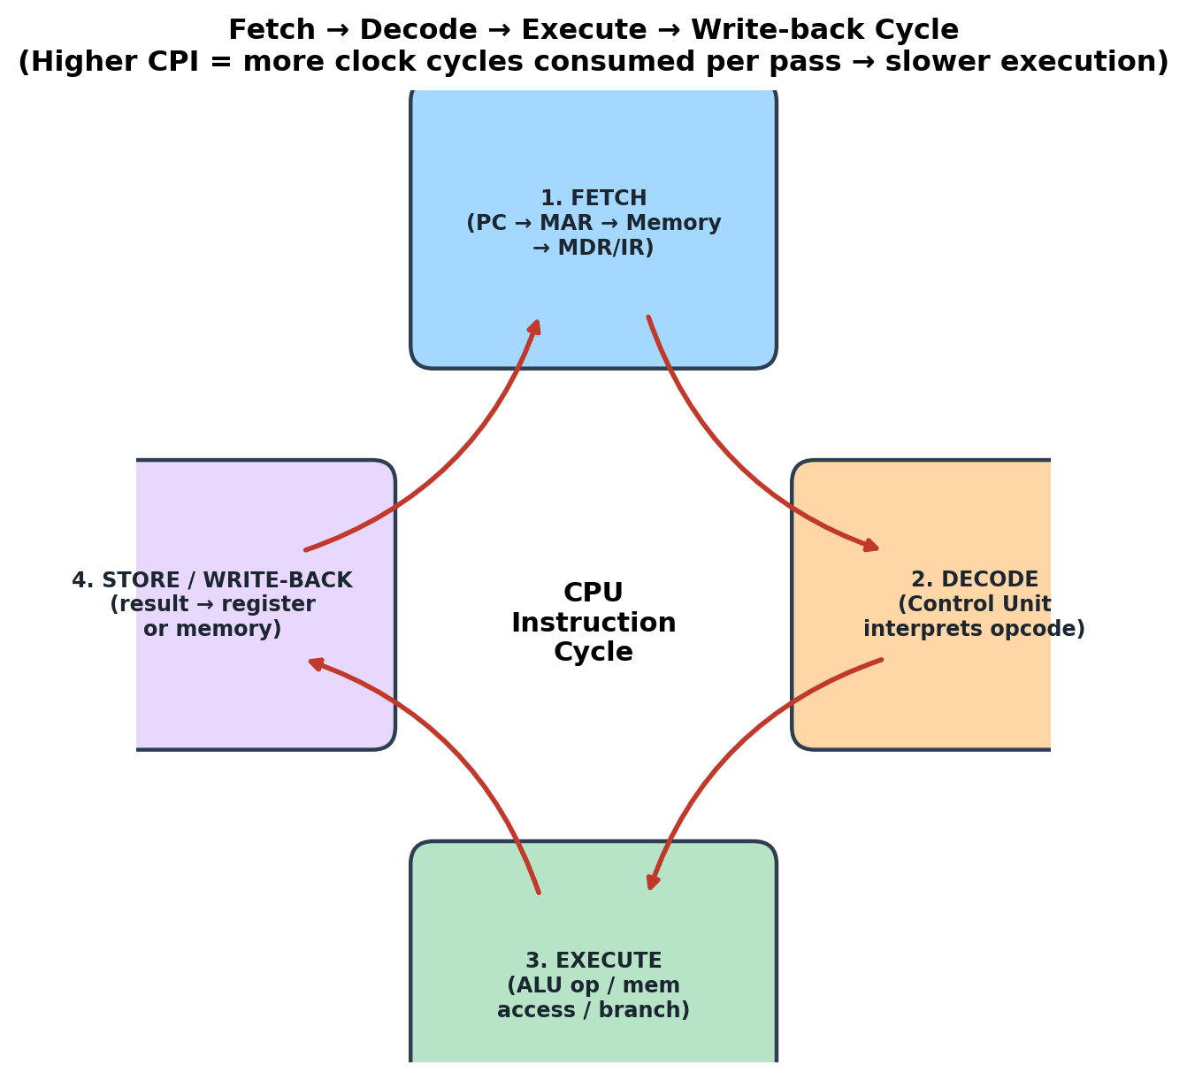
Figure 2.1 — The instruction cycle repeated for every instruction
- Fetch stage stalls: if the required instruction/data is not in cache, the CPU must wait many extra cycles for a main-memory access (a 'memory stall') — this alone can push CPI from ~1 up to 4–5 in memory-heavy code.
- Decode stage: complex instruction formats (variable-length, multiple addressing modes) take longer to decode, adding cycles.
- Execute stage — branch instructions: every conditional branch (e.g., 'if price > threshold') forces the CPU to determine the next PC only after evaluating a condition. If instructions were already fetched speculatively down the wrong path (pipeline), those fetched instructions must be flushed — a branch misprediction penalty of several cycles.
- Write-back / store: writing results back to memory (e.g., updating an order book entry) can again stall if memory is busy or not cached.
Because millions of instructions are executed per second, even a small average increase in CPI per instruction (extra memory-stall or branch-penalty cycles) multiplies into a large aggregate delay — this is the direct cause of the reported transaction-processing lag.

2.4 Methods to Reduce CPI / Improve Performance
- Instruction pipelining — overlaps fetch/decode/execute/write-back of successive instructions so, in steady state, close to one instruction completes per clock cycle instead of four.
- Multi-level caching (L1/L2/L3) — keeps hot order-book data and frequently executed matching-engine code close to the CPU, sharply cutting memory-access latency and hence memory-stall cycles.
- Branch prediction & branch target buffers — predict the likely outcome of conditional branches (e.g., using history of past trade decisions) so the pipeline is rarely flushed.
- Speculative / out-of-order execution — allows independent instructions to execute while a branch or memory operation is still resolving, hiding latency.
- Superscalar / multiple execution units — issue and execute more than one instruction per clock cycle.
- Register renaming & larger register files — reduce false data dependencies that otherwise stall the pipeline.
- Reducing memory access frequency algorithmically — batching/aligning data structures (e.g., order book) to reduce cache misses.

2.5 Code Output — Quantifying the Improvement
The Python model below applies the performance equation to a representative batch of 50 million instructions, comparing a naive design (CPI = 4.2, dominated by memory stalls and branch penalties) against the same processor after pipelining, caching, and branch prediction are applied (CPI reduced to 1.15).
def execution_time(ic, cpi, clock_freq_ghz):
clock_cycle_time_ns = 1 / clock_freq_ghz
total_cycles = ic * cpi
return (total_cycles * clock_cycle_time_ns) / 1e6 # -> ms
instruction_count = 50_000_000
cpi_before, clock_before = 4.20, 2.0 # naive design
cpi_after, clock_after = 1.15, 2.0 # pipelined + cache + branch prediction
t_before = execution_time(instruction_count, cpi_before, clock_before)
t_after = execution_time(instruction_count, cpi_after, clock_after)
speedup = t_before / t_after
Program Output:
============================================================
STOCK TRADING SYSTEM - CPU PERFORMANCE ANALYSIS
============================================================
Instruction count per batch : 50,000,000
BEFORE -> CPI = 4.20, Clock = 2.0 GHz
Execution time = 105.000 ms
AFTER -> CPI = 1.15, Clock = 2.0 GHz
Execution time = 28.750 ms
Speedup achieved = 3.65x faster
Latency reduced by = 72.6%
============================================================
This confirms that architectural enhancements alone (no change in clock frequency) can cut transaction-processing latency by roughly 73% purely by reducing CPI — validating pipelining, caching and branch prediction as the correct remedy.

2.6 Pipelining Effect — Visualized
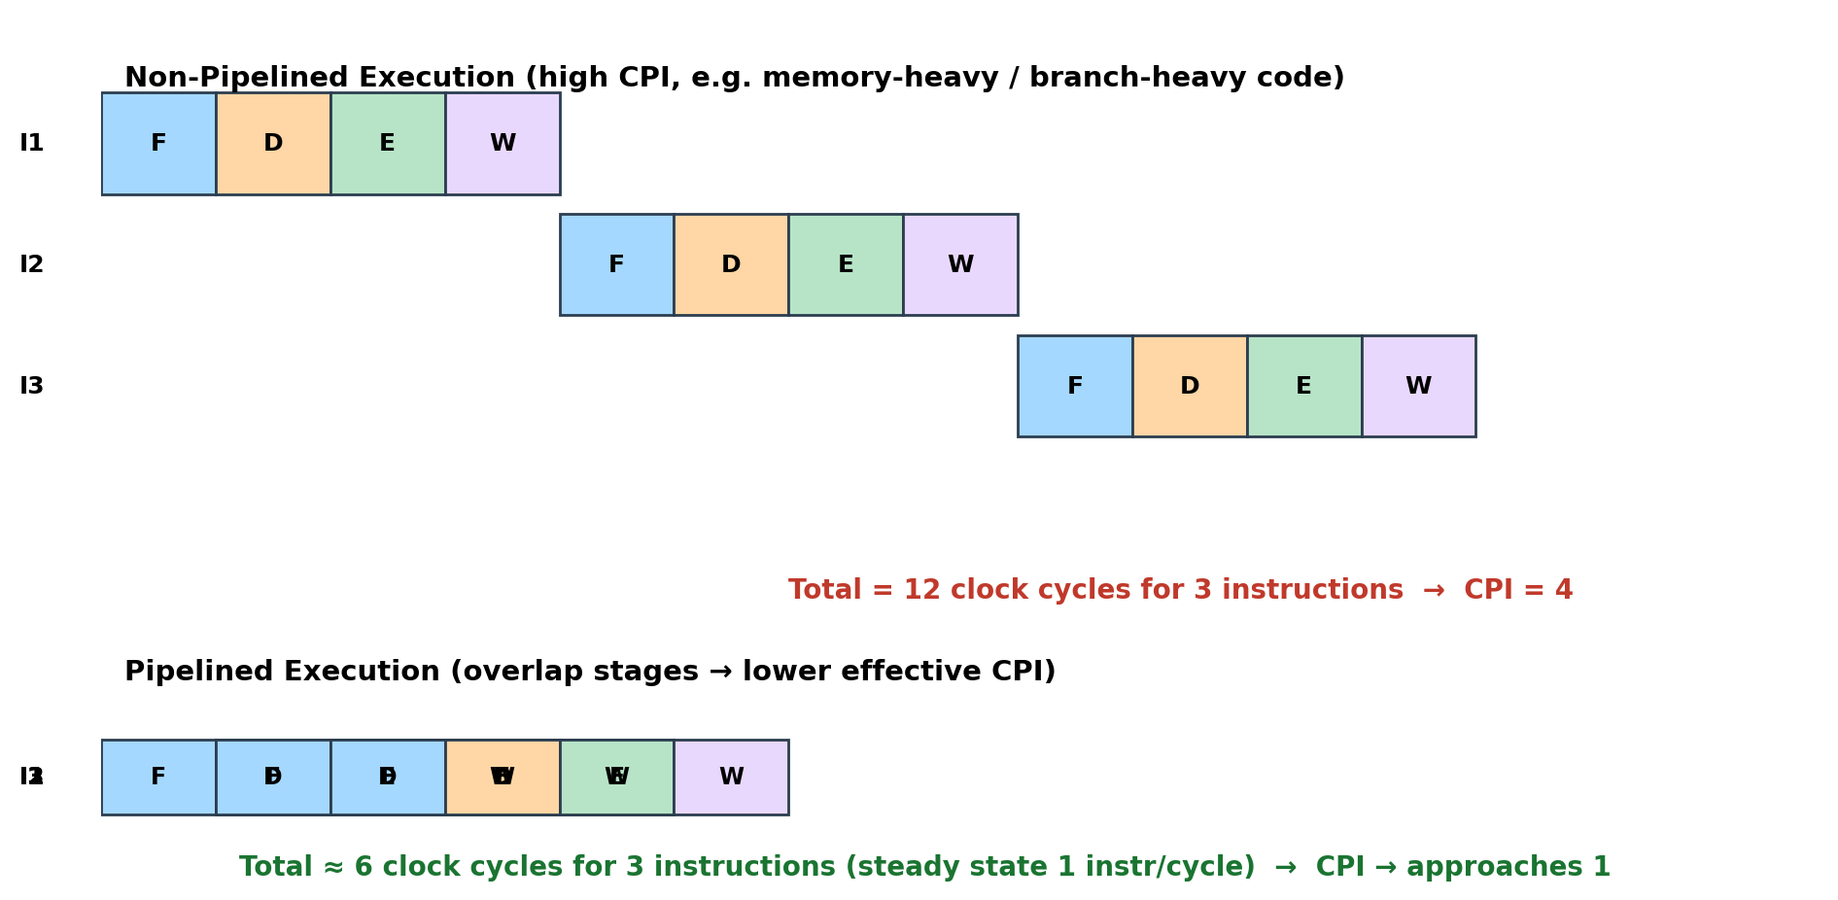
Figure 2.2 — Non-pipelined (CPI ≈ 4) vs pipelined (CPI → 1) execution of 3 instructions

2.7 Conclusion (Q2)
High CPI, caused by frequent memory stalls and branch instructions in the fetch–decode–execute cycle, is the root cause of trading-system delay under load. Pipelining, hierarchical caching, branch prediction, superscalar execution and register renaming together reduce effective CPI, directly lowering execution time per the performance equation and restoring real-time responsiveness.

Question 3: 8085-Based Temperature Control Unit — Addressing Modes & Reliability

3.1 Restating the Problem
An industrial temperature-control unit uses an 8085 microprocessor: sensors provide analog/digital temperature input (via an ADC/I/O port) and actuators (heater/cooler relay) respond based on processed values. Occasionally, incorrect temperature readings are processed — traced to improper use of addressing modes in the assembly program.

3.2 Addressing Modes of the 8085 and How They Affect Data Access
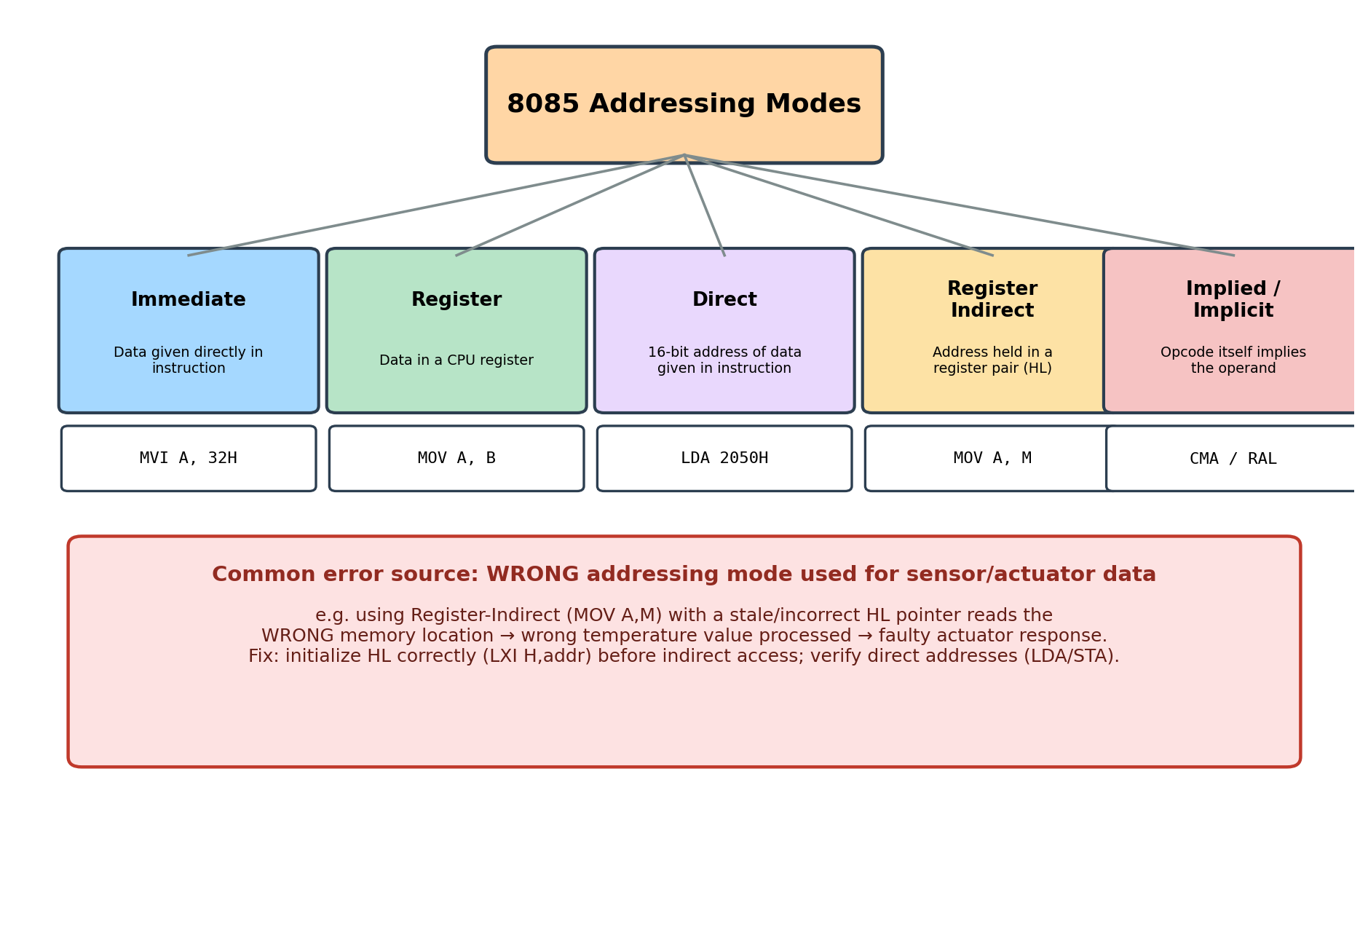
Figure 3.1 — 8085 addressing modes and example instructions
Mode | How Operand Is Located | Example | Typical Use in This System
Immediate | Data is part of the instruction itself | MVI A, 32H | Loading a fixed threshold/limit value
Register | Operand is inside a CPU register | MOV A, B | Moving a sensor value between registers for processing
Direct | Instruction contains the full 16-bit memory address | LDA 2050H | Reading/writing a fixed memory location, e.g. last sensor reading
Register Indirect | Address of data is held in register pair (usually H-L) | MOV A, M | Reading a value from a lookup/calibration table pointed to by HL
Implied / Implicit | Operand is implicit in the opcode (e.g., accumulator) | CMA, RAL, RRC | Bit manipulation of status/actuator control byte
Each mode determines exactly WHERE the CPU looks for data. Immediate and Register modes are fast and safe (no external address involved). Direct and Register-Indirect modes, however, depend on an address being correct — a small programming mistake here silently redirects the CPU to the WRONG memory cell, without any error being raised by the hardware.

3.3 Root Causes of the Faulty Readings
- Uninitialized / stale register pair in Register-Indirect mode: if HL is not (re)loaded with LXI H, addr before a MOV A, M or MOV M, A instruction, the CPU reads/writes whatever address HL happened to hold from a previous operation — producing a garbage 'temperature' value.
- Incorrect direct address in LDA/STA: a typo in the 16-bit address (e.g., LDA 2050H used instead of LDA 2060H) silently accesses the wrong memory cell — no crash occurs, just a wrong value being treated as valid sensor data.
- Confusing Immediate with Direct/Register mode: e.g., mistakenly using MVI A, 50H (loads the literal constant 50H) when the intent was to load the sensor value stored at address 50H, so a fixed dummy value is processed instead of the live reading.
- Not updating the pointer inside a loop: when scanning multiple sensor channels stored in consecutive memory locations, forgetting INX H after each MOV A, M causes the same location to be re-read repeatedly instead of advancing through the table.
- Sign/format mismatch: treating a signed BCD/two's-complement temperature byte as a plain unsigned direct value (or vice-versa) during comparison instructions (CPI, CMP) causes wrong threshold decisions even though the address itself was correct.

3.4 Using the 8085 Instruction Set Reliably — Recommended Practice
A corrected fragment reading a temperature sensor via a calibration/lookup table, comparing it to a threshold, and driving an actuator:
; ---- Reliable temperature-check routine (8085) ----
MVI A, 00H ; (Implied/Immediate) clear accumulator
LXI H, 3000H ; (Immediate, loads pointer) HL -> sensor buffer
MOV A, M ; (Register-Indirect) read live sensor byte via HL
MVI B, 4BH ; (Immediate) B = threshold constant (75 decimal)
CMP B ; (Register) compare A with threshold in B
JC HEATER_ON ; branch if reading below threshold
STA 2050H ; (Direct) log latest reading to fixed status cell
JMP DONE
HEATER_ON:
STA 2050H ; (Direct) still log the reading
MVI A, 01H ; (Immediate) actuator-ON command code
OUT 01H ; send command to actuator port
DONE: HLT
- Always initialize HL explicitly with LXI H before any Register-Indirect access — never assume its previous value.
- Double-check every hard-coded 16-bit address used with LDA/STA/SHLD/LHLD against the system's memory map.
- Use Immediate mode ONLY for genuine constants (thresholds, masks, command codes) — never for values that are supposed to come from a sensor/memory location.
- When scanning tables of multiple sensors, increment the pointer (INX H) each iteration and bound the loop with a counter (register B/C + DCR/JNZ).
- Add a simple range/sanity check on the value read (e.g., compare against known min/max valid temperature) before it is allowed to drive an actuator — this catches an addressing-mode error before it causes an unsafe physical action.

3.5 Conclusion (Q3)
The 8085's addressing modes give flexible but literal access to data: the CPU will faithfully read whatever address a Direct or Register-Indirect instruction points to, correct or not. Occasional bad temperature readings in this system are best explained by an unrefreshed HL pointer, a wrong hard-coded address, or confusing Immediate with Direct/Indirect access. Disciplined use of the instruction set — explicit pointer initialization, verified addresses, correct mode selection for constants vs. live data, and a sanity check before actuation — ensures accurate and reliable operation of the temperature-control unit.

